
INFOST 440 Flex

Contact Information: Dee Piziak/piziak@uwm.edu

Instructions:

- Read PowerPoint_3.

- Read the second half of Chapter 1.

- Create an index page: this index page will be your main (home) web page. It will have links to other web pages you create. For this week, this index page should have a link to the Welcome.php file which you created in assessment 2.
  - Using html code and any text editor like Notepad++, create an Index.html page and ftp it using FileZilla to your SOIS space on the server under the PHP_Flex folder you created in assessment 2. (i.e. public-html \PHP_Flex\Index.html)

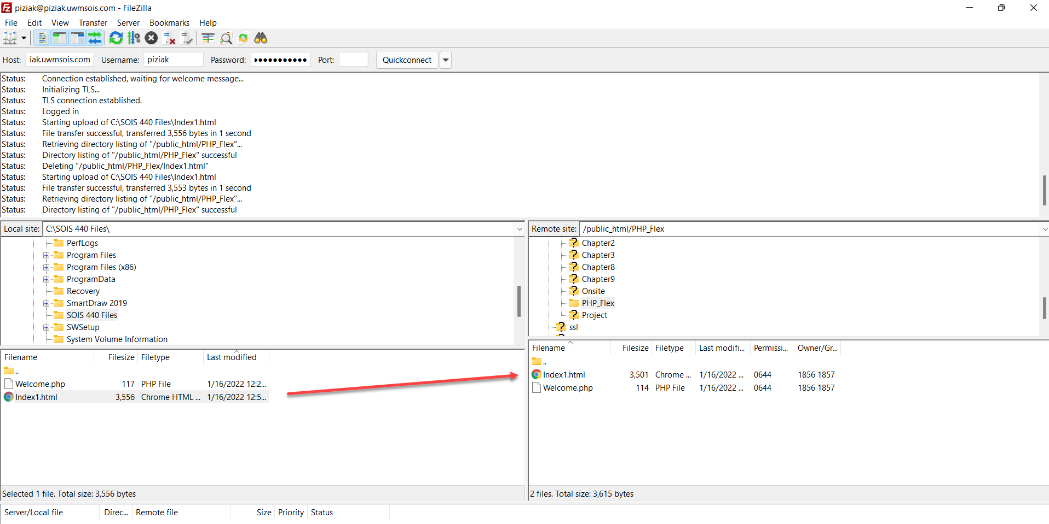

  - Because you may not be familiar with all the html syntax, click on the following link to run my index page which I called it here Index1.html, but you should call it Index.html: http://piziak.soisweb.uwm.edu/PHP_Flex/Index1.html
  - You can view the html code for the Index.html file by right clicking on html page after you open it and choosing View source. Please make sure you understand the code, not just copy it. This is an opportunity for some of you who are not so familiar with the html code to learn and understand the html code.
  - After you uploaded the file to your sois space using ftp, run your Index.html using your web browser. (Note: be careful when typing the address for your Index.htm file. It is case sensitive. So, Index.html is not the same as index.html). Your Index.html file should look like the image below

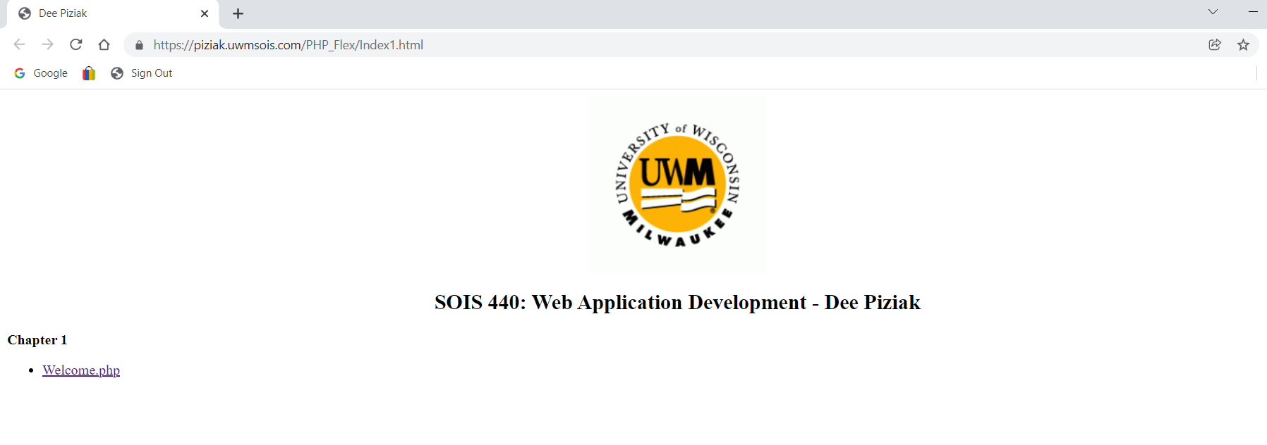

  - In the image above, I did the following (you can view the source code as I mentioned above):
    - Added an image to my Index.html file. Again, I called my file in the image above as Index1.html, but you should call it Index.html. Feel free to change the logo image if you want to be more creative about your Index.html file
    - Added the heading “SOIS 440: Web Application Development - Dee Piziak” to my Index.html file.
    - On the web server side, I created a subfolder called Chapter1 under the PHP_Flex folder and moved the Welcome.php file which I created in assessment 2 so it is under Chapter1 subfolder.

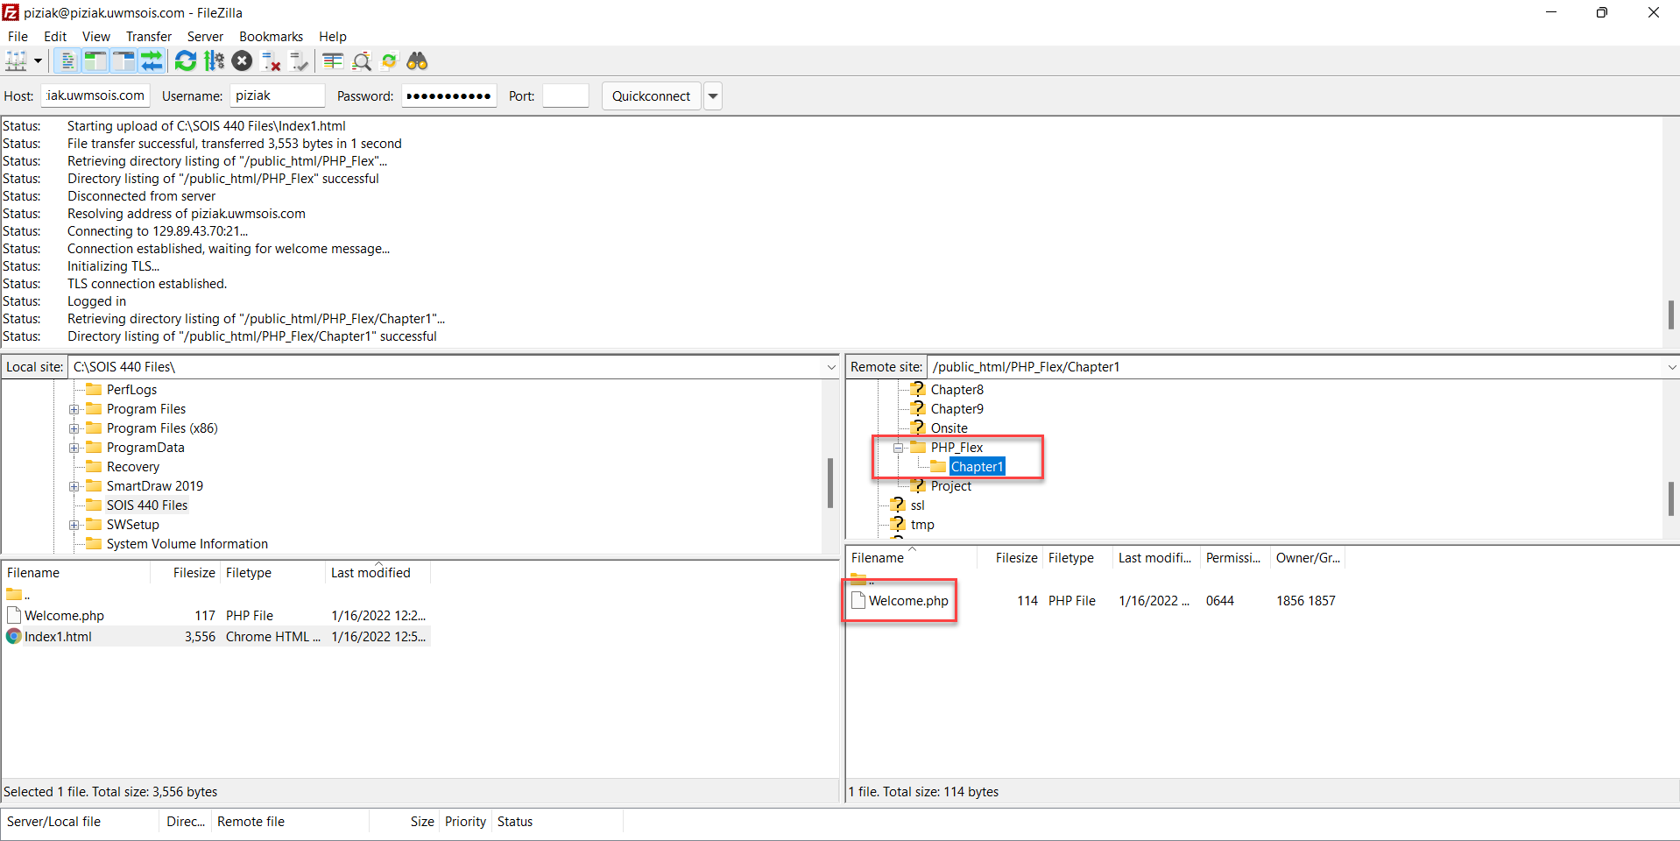

    - To create a subfolder under PHP_Flex, right click the PHP_Flex folder and choose Create directory.

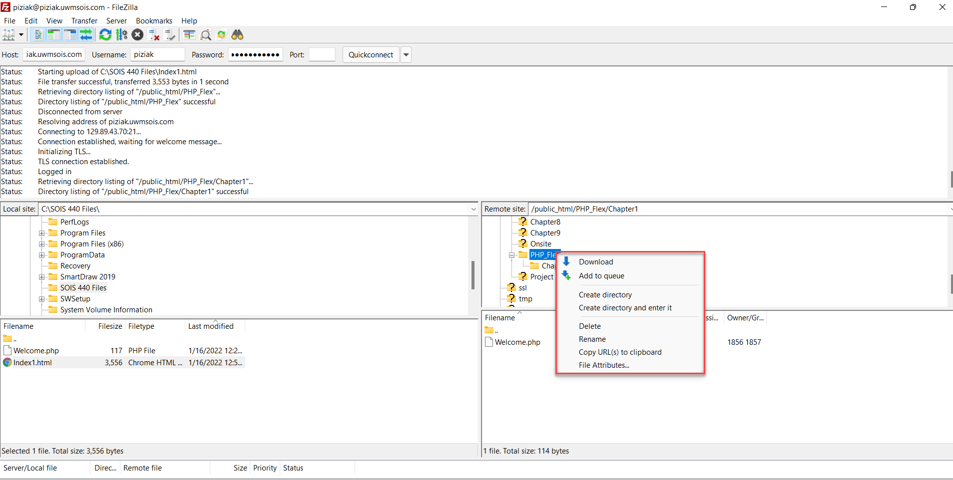

    - I also added a paragraph title to my Index.html file and called that title Chapter 1. Under Chapter 1 title, I added a list item which is a link to the Welcome,php file. So, when you click on this link you should see the Welcome,php file as can be seen in the image below:

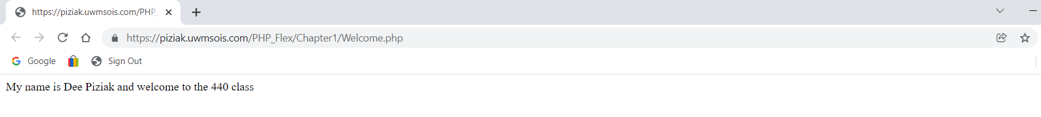

- Test your Index.html and also make sure the link to your Welcome.php file works.

- Upload the a text file containing the URL to your Index.html to the Assessment 3 drop box so I can try your Index.html and your Welcome.php file. Do not send me any screen shots, just the URL.

